**HIVE**

1. Which customer has expensive fraud transaction

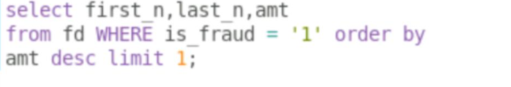2.which state has most no of fraud case

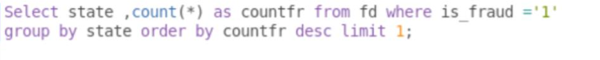3.Top states with highest female fraud transaction

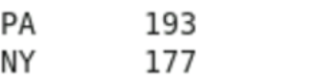

4. Count no of transaction per merchant for each fraud status



